API Gateway
Amazon API Gateway is a fully managed service that allows you to create, and monitor APIs (Application Programming Interfaces) at scale.
It acts as a “front door” for applications to access data, business logic, or functionality from your backend services like:
- AWS Lambda
- EC2 instances
- Other AWS services (e.g., DynamoDB, S3)
API Gateway Works
API Gateway as a traffic manager between your clients (mobile apps, web apps, IoT devices) and backend services.
Workflow:
- Client Request → A mobile app, browser, or system makes an HTTP(S) request to the API Gateway endpoint.
- API Gateway Processing:
  - Routes the request to the correct backend service.
  - Can transform requests/responses (e.g., JSON ↔ XML).
- Backend Integration → API Gateway calls your backend service (Lambda, EC2, DynamoDB, etc.).
- Response → The backend sends data back through API Gateway to the client.
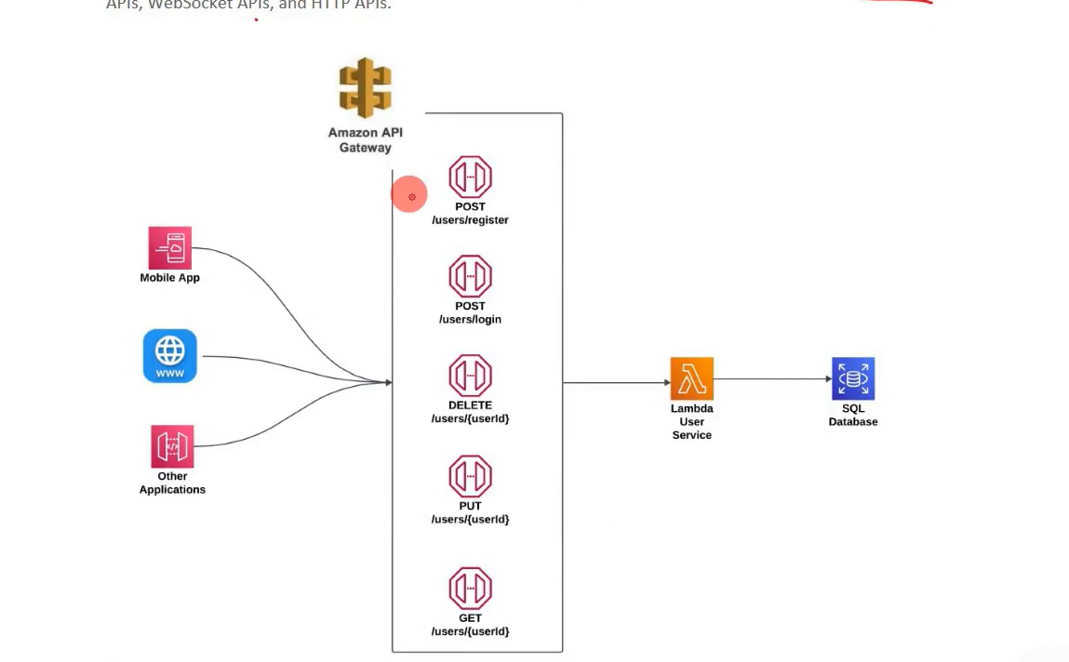

Why API Gateway is Used
Centralized API management – manage multiple APIs in one place.
Security – control access via IAM, Cognito, API keys.
Scalability – handles millions of requests automatically.
Performance – caching responses reduces backend load.
Cost-effective – pay only for API calls and data transfer.
Monitoring – integrates with CloudWatch for logging and metrics.

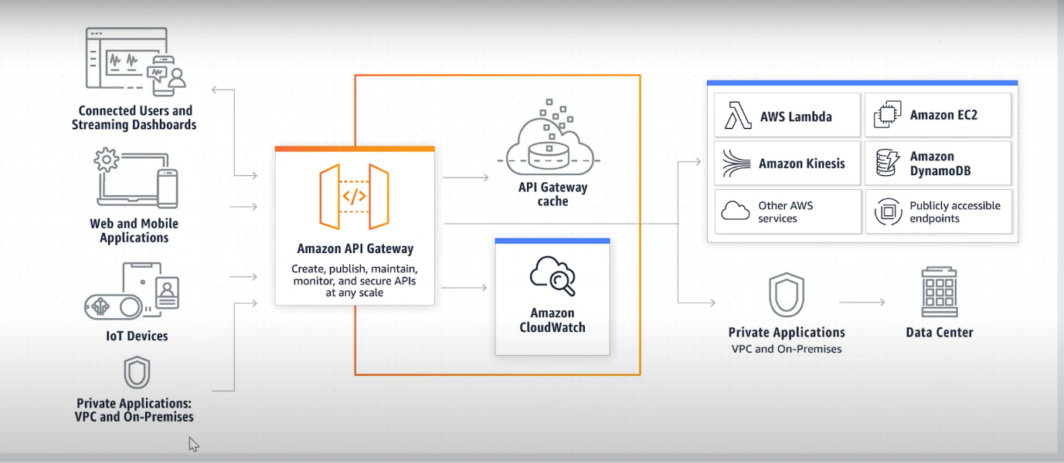

Create a REST API with API Gateway and Lambda

Step 1: Create a Lambda Function
Log in to the AWS Management Console.
Go to Lambda → Click Create function.
Choose Author from scratch:
Function name: MyLambdaFunction
Runtime: Python 3.x (or Node.js, Java — up to you).
In the code editor, paste a simple code
Click Deploy.
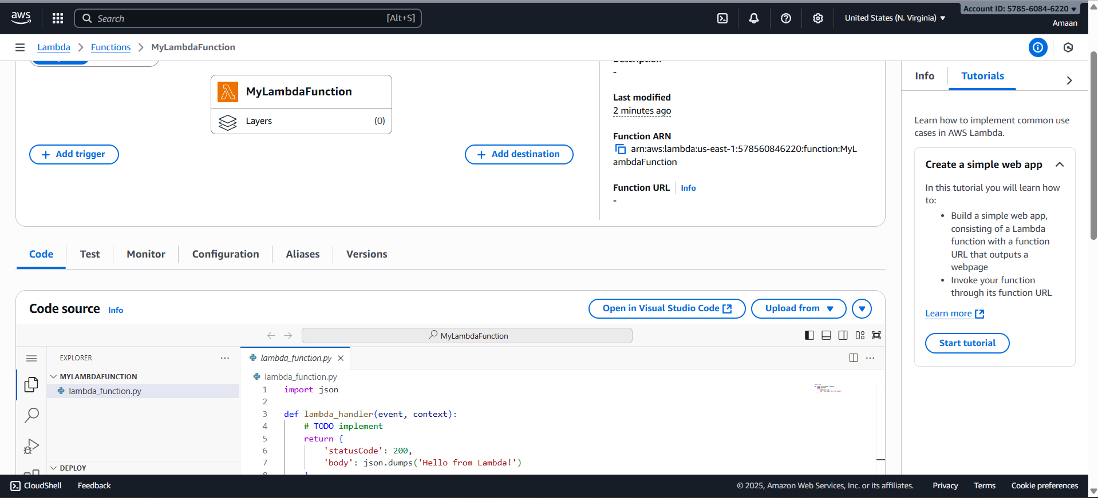
Step 2: Create an API Gateway
- Go to API Gateway in AWS Console.
- Click Create API → Select HTTP API (simpler than REST API).
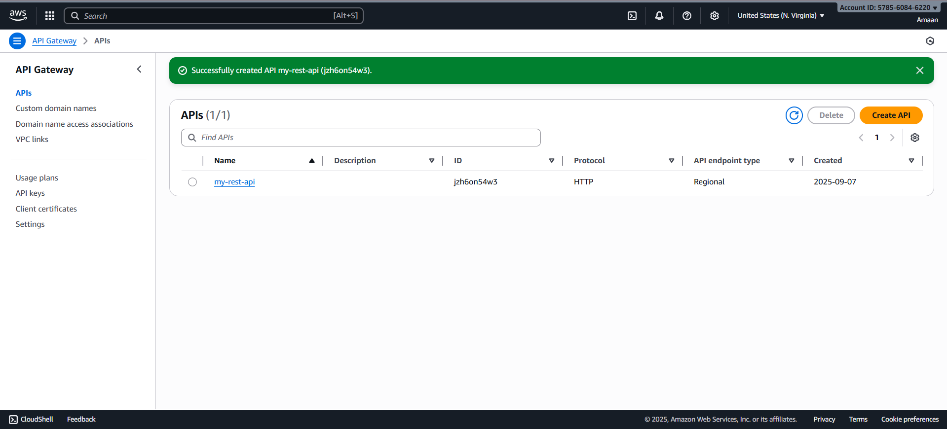

- In Integrations, select Lambda → choose your MyLambdaFunction.
- Click Next → Configure routes:
  - Method: ANY or GET
  - Resource path: /Dev
- Deploy the API.
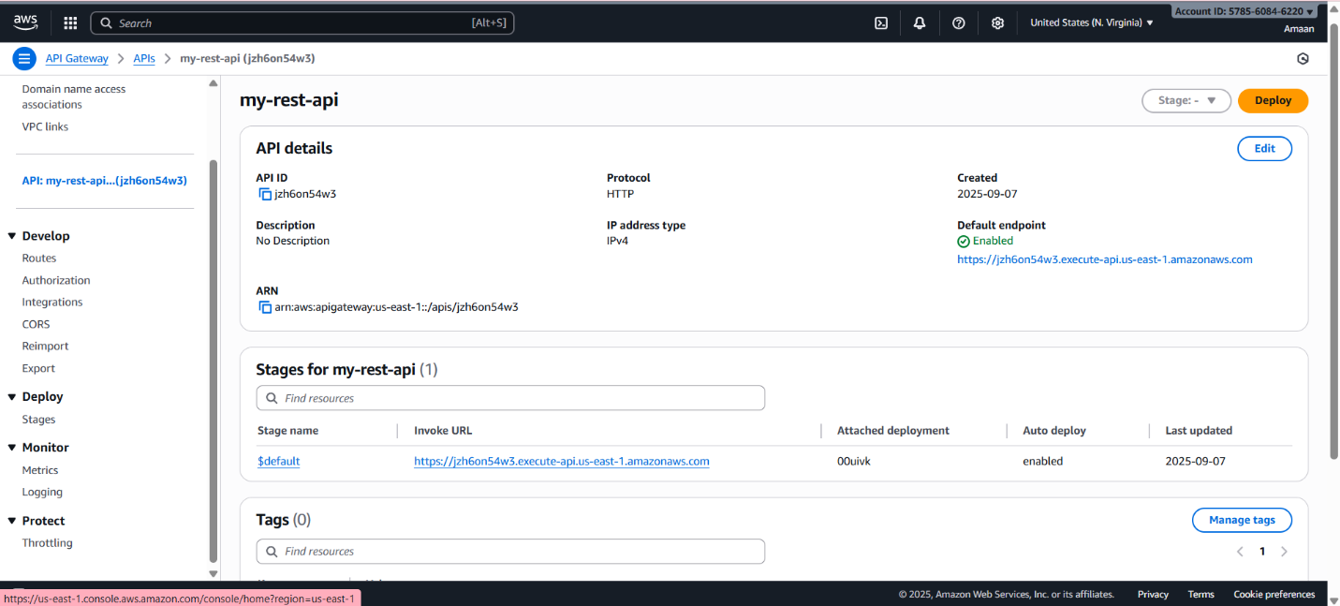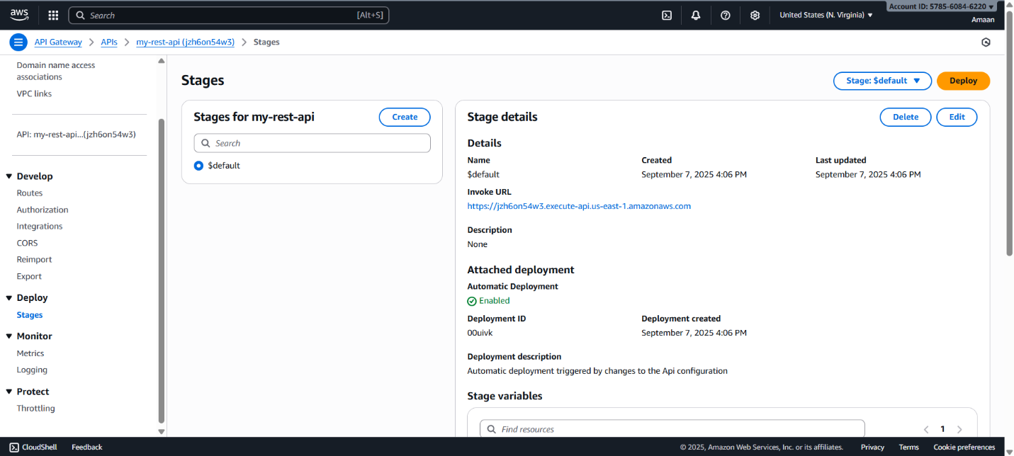

You’ll get an Invoke URL like:
https://jzh6on54w3.execute-api.us-east-1.amazonaws.com/

